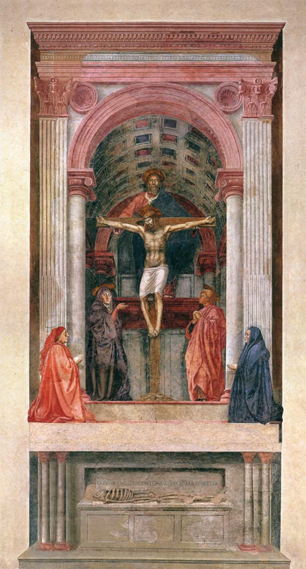

1.
Artist: Masaccio

Title: Trinity

Date: 1426-1427

Location: Santa Maria Novella (Florence)

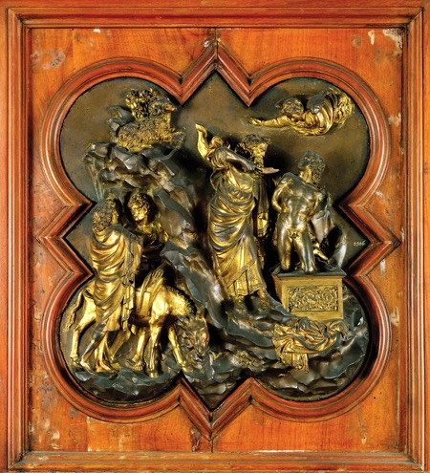

2.
Artist: Ghiberti

Title: Sacrifice of Isaac

Date: 1401-1403

Location: Florence

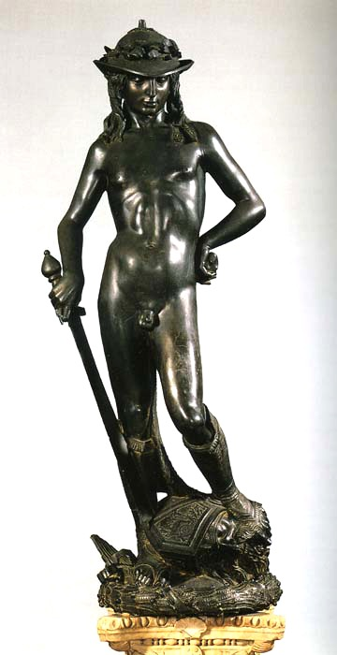

3.
Artist: Donatello

Title: David

Date: 1446

Location: Florence

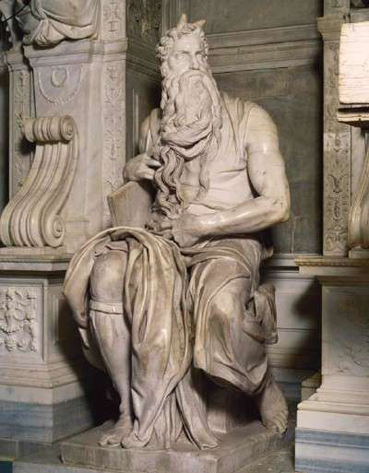

4.
Artist: Michelangelo

Title: Moses

Date: 1513-1516

Location: Rome

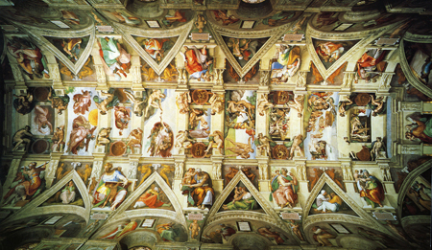

5.
Artist: Michelangelo

Title: Sistine Chapel Ceiling

Date: 1508-1512

Location: Vatican City

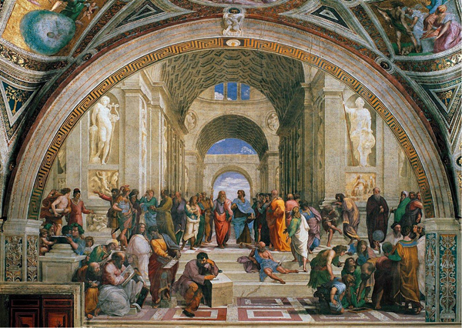

6.
Artist: Raphael

Title: School of Athens

Date: 1509-1511

Location: Vatican City

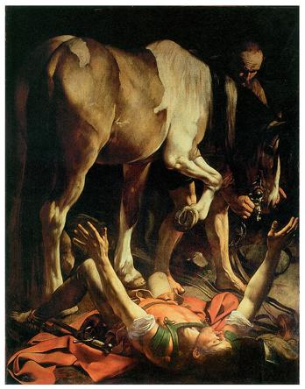
7.
Artist: Caravaggio

Title: Conversion of St. Paul

Date: 17th Century

Location: Rome

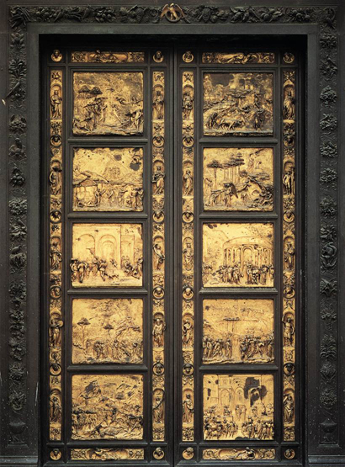
8.
Artist: Ghiberti

Title: Gates of Paradise

Date: 1450

Location: Baptistery of San Giovanni (Florence)
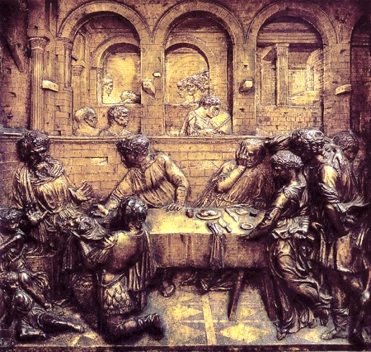

9.
Artist: Donatello

Title: Feast of Herod

Date: 1427

Location: Baptistery of San Giovanni (Florence)

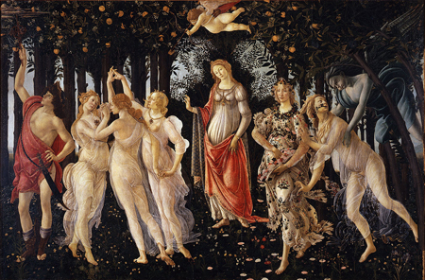

10.
Artist: Botticelli

Title: Primavera

Date: 1482

Location: Florence

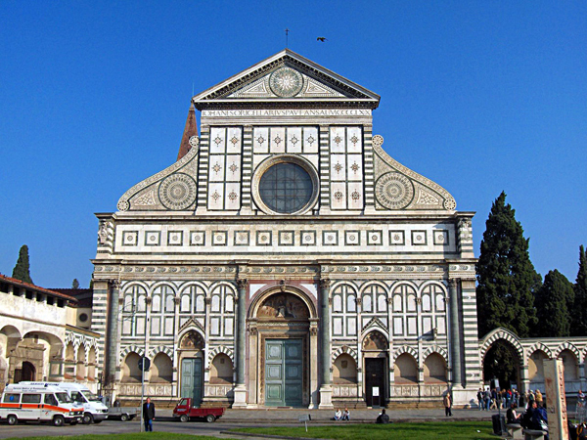
11.
Architect: Alberti

Title: Façade of Santa Maria Novella

Date: 1456

Location: Florence

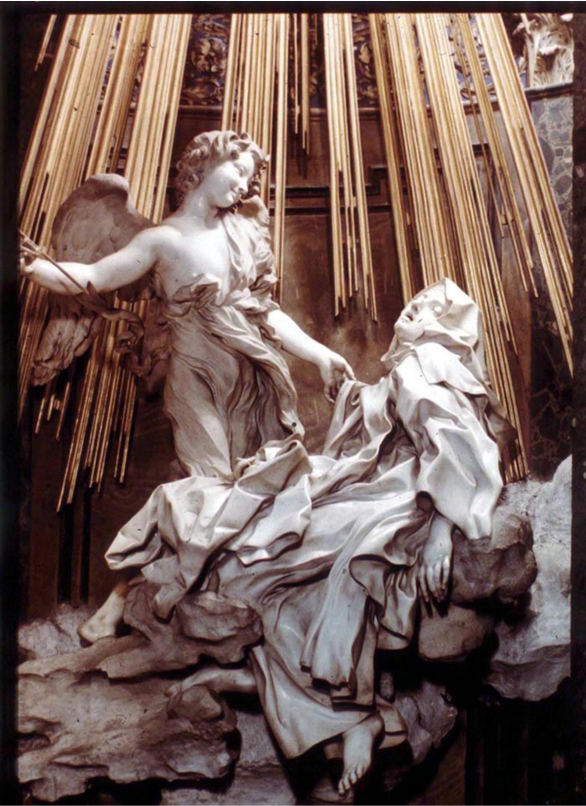

12.
Artist: Bernini

Title: Ecstasy of St. Theresa

Date: 1652

Location: Rome

